Names ______________________________________________________________________________
EDUC 2551 – Elementary School Math: Geometry
Project 4

1. | 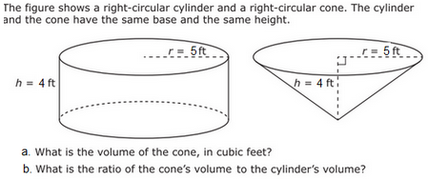
2. | Two dolphins are similar in shape. One is 4 ft long; the other is 1 ft long.  a. How many times heavier is the larger dolphin?  b. How many times more skin surface does the larger dolphin have?
3. | Find the total surface area and the volume of the triangular prism shown below.  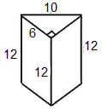
4. | In the figures below, the radius and height of each right circular cylinder are given. If w, x, and y represent the respective volumes of the cylinders, order these volumes (w, x, and y) from least to greatest.  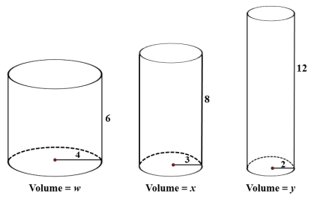
5. | 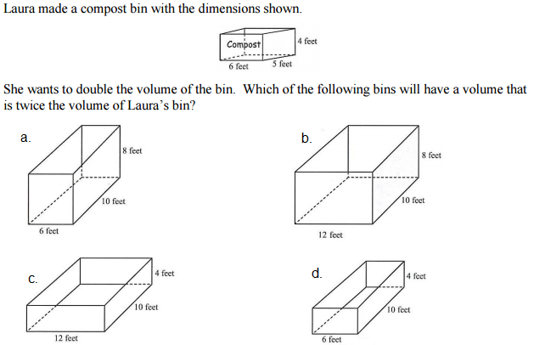
6. | 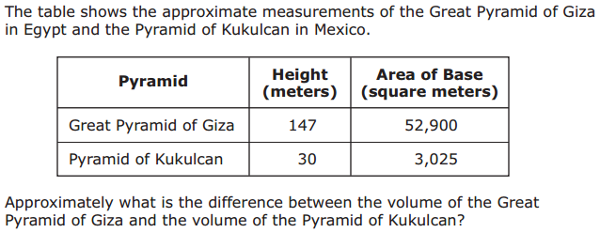
7. | 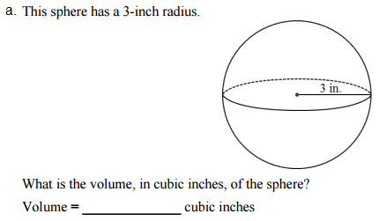  What is the volume of a hemisphere with the same radius in cubic inches?
8. | 